MAPARIA -NEWTON RECEIVED FOOD FROM WFP . The village is under quarantine for 21 days.

[[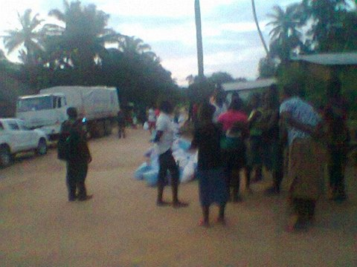](https://www.facebook.com/photo.php?fbid=798247276865175&set=pcb.798247320198504&type=1)](https://www.facebook.com/photo.php?fbid=798247276865175&set=pcb.798247320198504&type=1)

[[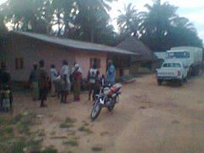](https://www.facebook.com/photo.php?fbid=798247273531842&set=pcb.798247320198504&type=1)](https://www.facebook.com/photo.php?fbid=798247273531842&set=pcb.798247320198504&type=1) [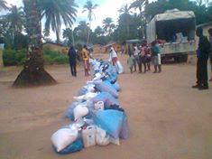](https://www.facebook.com/photo.php?fbid=798247270198509&set=pcb.798247320198504&type=1)

[[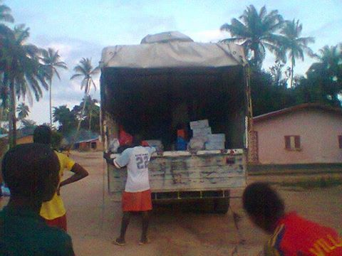](https://www.facebook.com/photo.php?fbid=798241533532416&set=pcb.798241566865746&type=1)](https://www.facebook.com/photo.php?fbid=798241533532416&set=pcb.798241566865746&type=1)

The District disease surveillance office handing over the report for the day to the In -charge of the Newton health center . The Hon Claude dressing the meeting this afternoon . The Kemokoh Conteh of water loo in black suit sitting waiting for his to address . A cross section of people present .

[[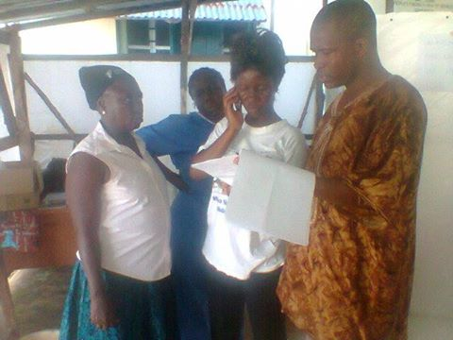](https://www.facebook.com/photo.php?fbid=798181666871736&set=pcb.798181700205066&type=1)](https://www.facebook.com/photo.php?fbid=798181666871736&set=pcb.798181700205066&type=1)

[[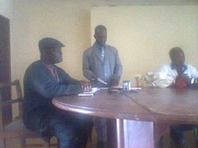](https://www.facebook.com/photo.php?fbid=798181663538403&set=pcb.798181700205066&type=1)](https://www.facebook.com/photo.php?fbid=798181663538403&set=pcb.798181700205066&type=1) [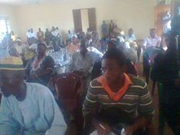](https://www.facebook.com/photo.php?fbid=798181660205070&set=pcb.798181700205066&type=1)

THE HON CLAUDE DM AMANDA DISGRUNTLED AS HE SITS ON THE GROUND ON THE STEPS IN THE DISTRICT COUNCIL HALL . But this is a message for the CHIEF WEEP . District health management team need to do more . HON CHIEF WEEP YOUR TAKE SIR ! The other pictures shows the empty council hall and water loo health center.

[[](https://www.facebook.com/photo.php?fbid=798053713551198&set=pcb.798053743551195&type=1)](https://www.facebook.com/photo.php?fbid=798053713551198&set=pcb.798053743551195&type=1)

[[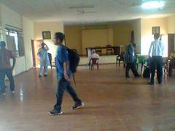](https://www.facebook.com/photo.php?fbid=798053710217865&set=pcb.798053743551195&type=1)](https://www.facebook.com/photo.php?fbid=798053710217865&set=pcb.798053743551195&type=1) [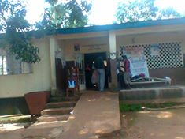](https://www.facebook.com/photo.php?fbid=798053706884532&set=pcb.798053743551195&type=1)